Ulei Semi Sintetic

NR. CRT. | NUME PRODUS | IMAGINE | PRET/BUC
 | Castrol Magnatec 10W40 A3/B4 - 1 Litru | 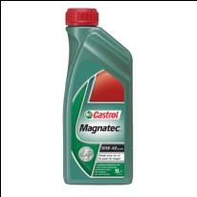 | 30,00 RON
 | Castrol Magnatec 10W40 A3/B4 - 4 Litri | 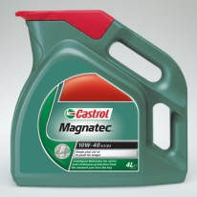 | 107,00 RON
 | Castrol Magnatec 10W40 A3/B4 - 5 Litri | 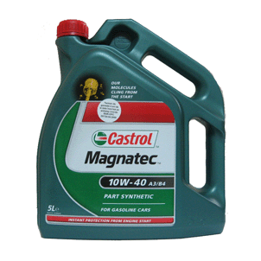 | 120,00 RON
 | Castrol Magnatec 10W40 Diesel B4 - 1 Litru | 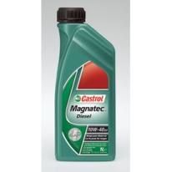 | 30,00 RON
 | Castrol Magnatec 10W40 Diesel B4 - 4 Litri | 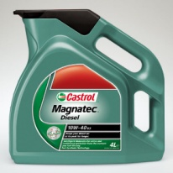 | 105,00 RON

